**A MINOR PROJECT REPORT ON**

**INFOMANIA**

**CHABOT WITH FACIAL RECOGNITION**

**A thesis submitted in partial fulfillment of the requirements for the award of the degree of**

**Bachelor of Technology**

**In**

**Computer Science and Engineering**

By

**CHANDAN LAL PN (ENG17CS0055)**

**DHRUV PAI (ENG17CS0069)**

**HARSH GUPTA (ENG17CS0084)**

**Under the Guidance of**

**Dr SANJAY CHITNIS**

**(Director of Innovation Labs)**



**DEPARTMENT OF COMPUTER SCIENCE AND ENGINEERING DAYANANDA SAGAR UNIVERSITY**

**Kudlu Gate, Hosur Road, Bangalore-560081**

**DECEMBER-2019**

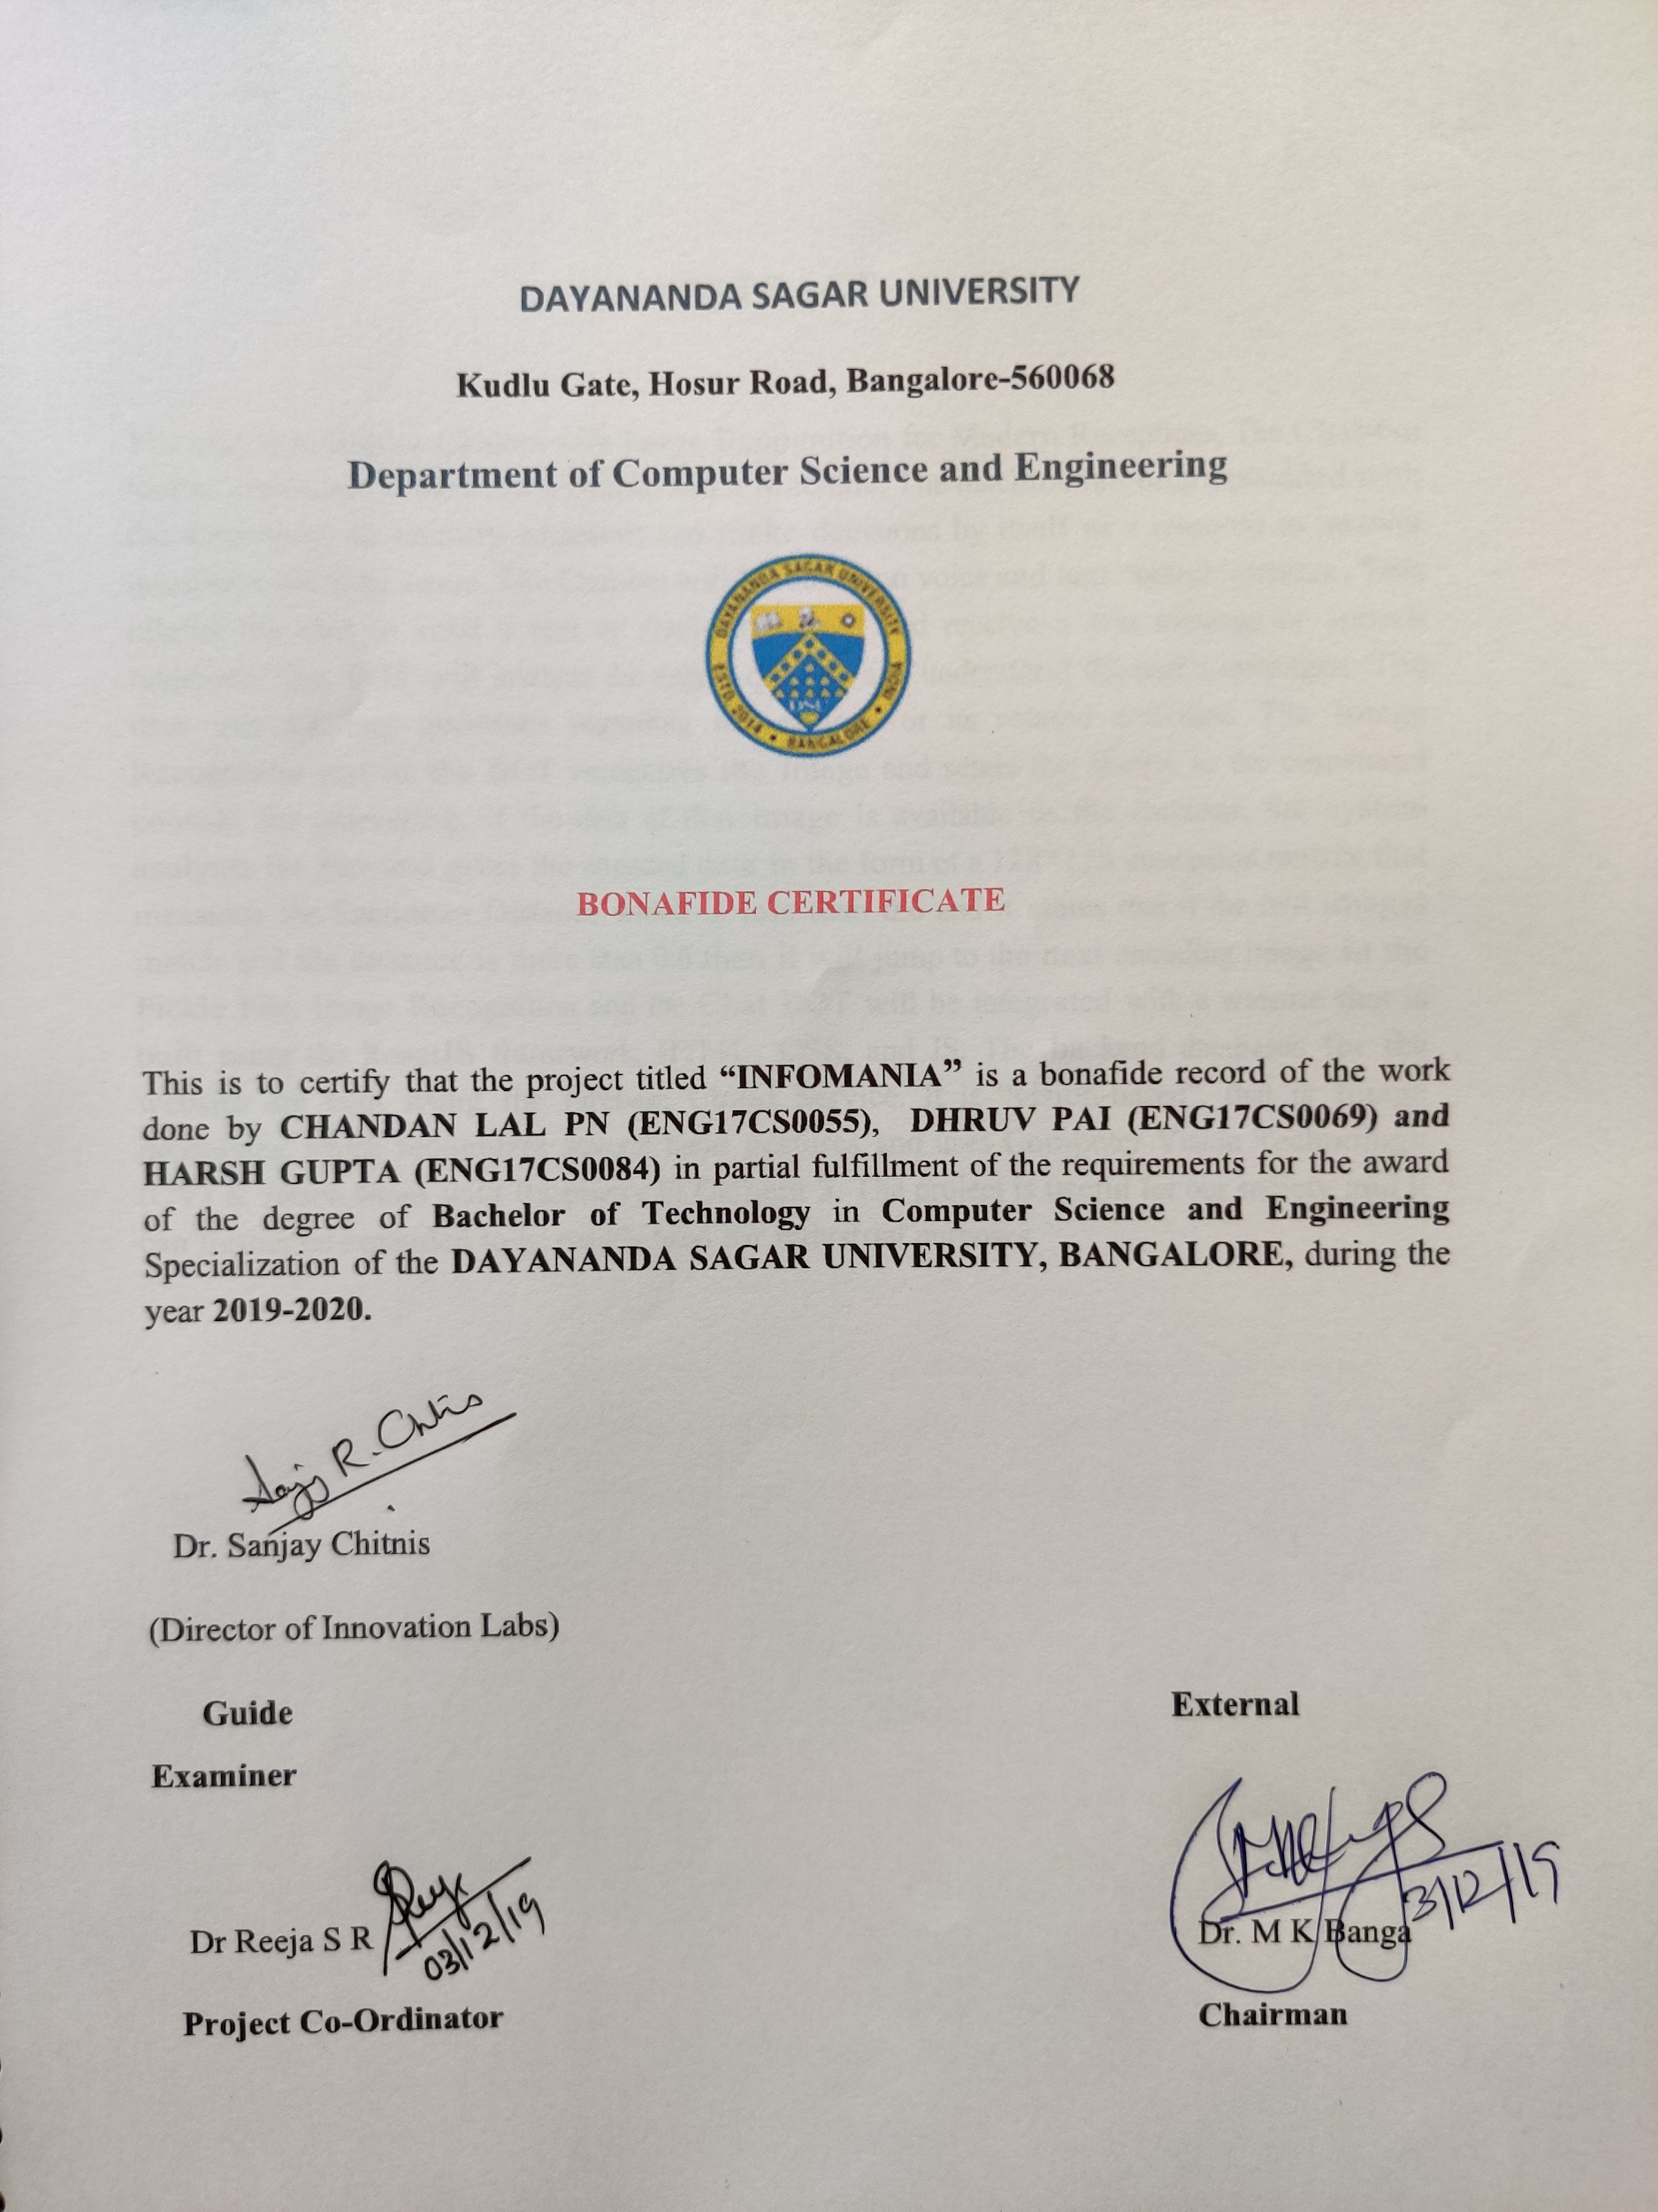

**ABSTRACT:**

The aim is to build a Chatbot with Facial Recognition for Modern Receptions. The Chat-bot makes conversation between a Human and a Machine. The machine has been embedded with the knowledge to identify sentences and make decisions by itself as a response to answer questions asked by users. The Chat-bot will be based on voice and text control interface. This allows the user to send a text or Audio message and receive a text message or speech response. The BOT will analyze the user’s queries and understand the user’s messages. The user can ask any questions regarding the college or its related activities. The Image Recognition part of the BOT recognizes the Image and sends the frames to the command console for processing, if the data of that image is available in the database, the system analyzes the face and gives the encoded data in the form of a 128*128 dimension matrix that measures the Euclidean Distance which is less than 0.6 and it states that if the two images match and the distance is more than 0.6 then it will jump to the next encoding image in the Pickle File. Image Recognition and the Chat BOT will be integrated with a website that is built using the Wordpress Bitnami. The backend databases for the website are built using the Firebase Cloud Service. It is “vision-based”, that is Image processing which recognizes several hand gestures and uses Computer Vision Technology (CV). The project is useful for our society and it can further be expanded to be readily used for industrial purposes.

i

**ACKNOWLEDGEMENTS**

I express my sincere thanks and gratitude to my university DAYANANDA SAGAR UNIVERSITY for providing me with an opportunity to fulfill my most cherished desire of reaching my goal and thus helping me to make a bright career.

I am grateful to my project guide **Dr Sanjay Chitnis** Director of Innovation Labs, Bangalore for his valuable guidance, encouragement and for extending all possible help in timely completion of the project.

I would also like to express my sincere gratitude to my project coordinator **Dr Reeja S R, Associate Professor,** Department of Computer Science & Engineering, DSU for the support for my B.Tech Study and Research.

I am highly grateful **to Dr M.K Banga, Chairman**, Department of Computer Science and Engineering, DSU, Bangalore for his kind support, guidance and encouragement throughout the course of this work.

I express my heartfelt thanks to **Dr A Srinivas, Dean** at the esteemed institution DSU Bangalore for providing me with an opportunity to reach my goal.

I would like to thank all the teaching and non-teaching staff of the Department of Computer Science and Engineering for their kind cooperation during the course of the work. The support provided by the Departmental library is gratefully acknowledged.

Finally, I am thankful to my parents and friends, who helped me in one way or the other throughout my project work.

CHANDAN LAL PN (ENG17CS0055)

DHRUV PAI (ENG17CS0069)

HARSH GUPTA (ENG17CS0084)

ii

**DECLARATION**

We **CHANDAN LAL PN (ENG17CS0055), DHRUV PAI (ENG17CS0069) and HARSH GUPTA (ENG17CS0084)** students of 5th semester **B.Tech in Computer Science and Engineering,** **Dayananda Sagar University,** Bengaluru, hereby declare that titled **“INFOMANIA”** submitted to the Dayananda Sagar University during the academic year 2019-2020, is a record of an original work done by me under the guidance of **Dr.Sanjay Chitnis, Director of Innovation Labs,** Department of computer science engineering, Dayananda Sagar University, Bengaluru. This project work is submitted in partial fulfilment for the award of the degree of Bachelor of Technology in Computer Science. The result embodied in this thesis not been submitted to any other university or institute for the award of any degree.

Chandan Lal (ENG17CS0055)

Dhruv Pai (ENG17CS0069)

Harsh Gupta (ENG17CS0084)

Date:

Place: Bengaluru iii

**TABLE OF CONTENTS**

**Title Page No.**

**ABSTRACT…………………………………………………………………………………i**

**ACKNOWLEDGEMENTS………………………………………………………………..ii**

**DECLARATION…………………………………………………………………………...iii**

**TABLE OF CONTENTS…………………………………………………………………..iv**

**LIST OF FIGURES…………………………………………………………………………v**

**1 INTRODUCTION…………………………………………………………………………1**

1.1 Problem Statement………………………….……………………………….…..2

1.2 Objective of the Project………………………………………………….…….….2

1.3 Scope of the Project……………………………………..……………….…….….2

**2 LITERATURE REVIEW…………………………………………..…………….….…….3**

**3 REQUIREMENT SPECIFICATIONS…….…………………………………...………..5**

3.1 Hardware and Software Requirements…………………………..………..……...5

3.1.1 Hardware Requirements…………………………………………….….5

3.1.2 Software Requirements………………………………..………….….…5

3.2 Functional and Non-Functional Requirements……………………….…….….…5

3.2.1 Functional Requirements……………………………………………….5

3.2.2 Non-Functional Requirements………………………………………….6

**4 SYSTEM MODELS……………………………………………………………………….7**

4.1 Design of the Project……………….………………,…………………………….7

4.2 Use-Case Diagram………………………………….………….…………8

4.3 Sequence Diagram…………………………………………..……………………9

**5 IMPLEMENTATION……………………………………………………..…………….10**

5.1 System Architecture………..…………………………………………….………10

5.2 Procedure……..……………………….………………………………….………10

5.3 Pseudo Code……………………………………………………………….….11

**6 RESULTS / SCREENSHOTS…………………….……………………………………16**

**7CONCLUSION AND FUTURE SCOPE………………………………………..…….…18**

7.1 Conclusion….……………………………..…………………………………….18

7.2 Future Scope….…………………………………….…………………………….18

**8 REFERENCES………….……………….………………………………………………..19**

**LIST OF FIGURES**

**Figure NO. Title Page No.**

Fig 2.1 College Management System 03

Fig 4.1 Design of the project 07

Fig 4.2 Use-Case Diagram 08

Fig 4.3 Sequence Diagram 09

Fig 5.1 System Architecture 10

Fig 6.1 Facial Recognition of Unknown Faces 16

Fig 6.2 Facial Recognition of Known Faces 16

Fig 6.3 Facial Recognition of Unknown Faces 17

Fig 6.4 Infomania Website With Chatbot 17

**CHAPTER 1**

**INTRODUCTION**

A chatbot (also known as a talkbot, chatterbox, Bot, IM bot or Artificial Conversational Entity) is a computer program that mimics human conversations in its natural format including text or spoken language using artificial intelligence techniques such as Natural Language Processing (NLP), image and video processing, and audio analysis. Chat-bot for college management system project will be developed using artificial intelligence algorithms that will analyze users queries. This system will be a web application which will provide answers to the analyzed queries of the user. Users will just have to select the category for queries and then ask the query to the bot that will be used for answering it. Artificial intelligence will be used to answer the user's queries. The user will get the appropriate answers to their queries. The answers will be given using artificial intelligence algorithms. Users won't have to ask a receptionist in the college for inquiry.

The Users have to register to the system and has to login to the system. For registering the user will have to use the facial recognition system which checks if a user is registered in the college database or not. If the user’s face is not present then he is provided with a link to a website that has the registration page and the Chatbot. After login user can access the various helping pages. There will be various helping pages through which the user can chat by asking queries related to college activities. The system will reply to the user with the help of effective graphical user interface (GUI). The user can query about the college-related activities with the help of this web application. College-related activities such as annual day, sports day, Intake and other cultural activities. It will help the students/user to be updated about college activities.

When a parent visits a college/university then he/she doesn’t know where the staff room is or where a particular lecturer’s cabin is, hence the system has been integrated with an indoor maps system which is embedded in the website. This shows them the directions to a particular cabin in a college, hence saving the time of a parent and efficiently leading them to their destination. If a parent doesn’t know who he wants to meet and has a general idea like anybody in the computer science department the chatbot will use artificial intelligence and decide whom the parent needs to meet.

The college inquiry system will provide the response by summarizing the query and then output answers, it also provides selective information what the user wants. A college system will dispense all answers relating to domains such as admission, examination cell, notice board, attendance, placement cell and other miscellaneous domains.

Page No.1

1.1. **Problem Statement**

A Chatbot With Facial Recognition Providing a Virtual Assistant for Better Management, Communication & Efficiently Improving the interaction with the Client.

1.2 **Objective of the Project**

Infomania is a Conversational bot with Facial Recognition ie a computer program that mimics human conversations in its natural format including text or spoken language using Artificial Intelligence, Machine Learning & Deep Learning. Chatbot for college management system project will be developed using artificial intelligence algorithms that will analyze users queries using Natural Language Processing (NLP).

Facial Recognition for college management system project will recognize the image and store the data of the image in the database using Deep Learning. Infomania will be a web application which will provide answers to the analyzed queries of the user.

1.3 **Scope of the Project**

Chatbots or conversational AI is touted to be the future of the Industry. But chatbots do have some limitations, there is a lot of criticism about how Chatbot adds more taps and friction than conventional UI; consequently, it´s not convenient for users. As companies realize that NLP has still a long way to go, there is a new approach to solving the problems from User Experience perspective. Instead of relying only on natural language interaction, with Conversational Interface we can have a richer and more dynamic user experience.

Page No.2

**CHAPTER 2**

**Literature Survey**

[1] tells us about ways to ease the College Information Retrieval System for users. They came up with a chat-bot made using AIML (Artificial Intelligence Markup Language) and NLP. This Chat-bot could effectively answer College-related queries with an added advantage that it also provides personal info. like grades, etc. with proper user authentication. So the user gets the desired information quickly without having to go through a series of webpages.

[2] approach simplifies the chat-bots realization by using two solutions. First one is the ontology, which is exploited in a twofold manner: to construct answers very actively as a result of an deduction process about the domain, and to automatically populate, off-line, the chat-bots KB with sentences that can be derived from the ontology, describing properties and relations between concepts involved in the dialogue. Second is to preprocess of sentences given by the user so that it can be reduced to a simpler structure that can be directed to existing queries of the chat-bots. Their aim is to provide information regarding products of interest supporting consumers to get what they want exactly. Their choice was to implement a QA system using pattern-matching chatbot technology.

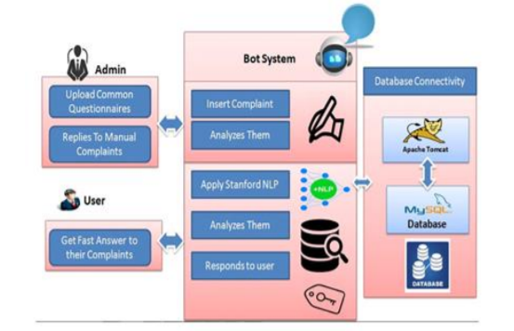

**Figure (2.1)College Management System[2]**

Page No.3

[3]In this work, we are presented with a novel approach to face recognition which considers both shape and texture information to represent face images. The face area is first divided into small regions from which Local Binary Pattern (LBP) histograms are extracted and concatenated into a single, spatially enhanced feature histogram efficiently representing the face image. The recognition is performed using the nearest neighbour classifier in the computed feature space with Chi-square as a dissimilarity measure. Extensive experiments clearly show the superiority of the proposed scheme overall considered methods (PCA, Bayesian Intra/extrapersonal Classifier and Elastic Bunch Graph Matching) on FERET tests which include testing the robustness of the method against different facial expressions, lighting and ageing of the subjects. In addition to its efficiency, the simplicity of the proposed method allows for very fast feature extraction.

[4]We are presented with an approach to the detection and identification of human faces and describe a working, near-real-time face recognition system which tracks a subject’s head and then recognizes the person by comparing characteristics of the face to those of known individuals. This approach treats face recognition as a two-dimensional recognition problem, taking advantage of the fact that faces are normally upright and thus may be described by a small set of 2-D characteristic views. Face images are projected onto a feature space (“face space”) that best encodes the variation among known face images. The face space is defined by the “eigenfaces”, which are the eigenvectors of the set of faces; they do not necessarily correspond to isolated features such as eyes, ears, and noses. The framework provides the ability to learn to recognize new faces in an unsupervised manner.

Page No.4

**CHAPTER 3**

**REQUIREMENT SPECIFICATION**

**3.1 Hardware and Software Requirements**

**3.1.1 Hardware Requirements:**

* A computer with at least 2 GHz processor.
* Minimum of 1GB Ram.
* 200MB of available memory available in Hard disk.
* A camera module.

**3.1.2 Software Requirements:**

* Windows operating system 32/64 or Linux.
* OpenCV Version 3.2.8
* DialogFlow.
* Kommunicate

**3.2 Functional and Non-Functional Requirements**

3.2.1 **Functional Requirements:**

The functional requirements are the requirements analysis based on the functional aspects of the system or specific behavior of the system.

* Facial Recognition: The user should stand in front of the camera and check if his face exists in the database.
* Recognized User: If recognized the user will be prompted with a barcode which leads to the website.
* Guest User: If the user is not recognized then he will be led to a google form to fill up so that his details are stored.
* Chatbot: The user then interacts with a chatbot to get the desired information.

Page No.5

3.2.2 **Non-Functional Requirements:**

* Cost: The system is completely cost-free for users. For developers, the cost of construction is limited to the camera and dialogflow which is free only for a limited amount of time.
* Security: All the data involved in the system are securely stored on Google servers, hence all security is provided by Google.
* Quality: The software is design to provide the best output as it uses AI hence it learns as it progresses.
* Reliability: The exceptions in the software are completely handled and refined for better user interaction during usage.

Page No.6

**CHAPTER 4**

**SYSTEM MODELS**

**4.1 Design of the Project:**

`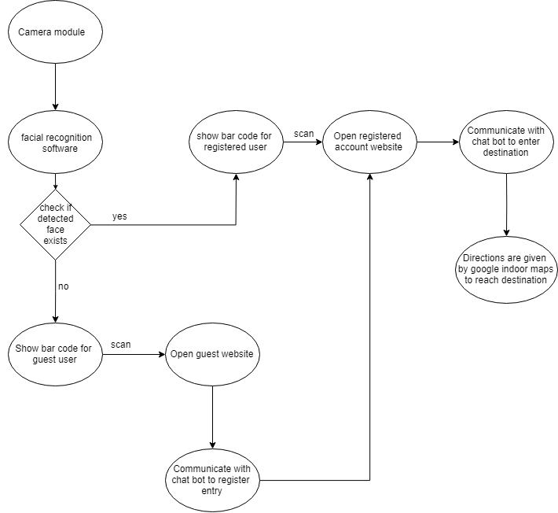

**Figure 4.1**

Page No.7

**4.2 Use-Case Diagram:**

Use-Case diagram is used to represent the relationship between the sender and the receiver and the processes that take place in the system on the sender’s end and the receiver’s end. Figure (4.2) gives the Use-Case diagram.

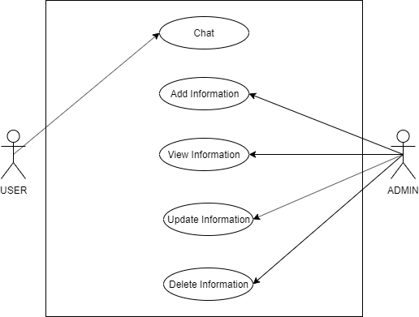

**Figure (4.2)**

Page No.8

**4.3 Sequence Diagram**

The sequence diagram represents the interactions and data flow between the functions or objects in a sequence manner. Here the Figure (4.4) illustrates the flow from the sender ton the receiver.

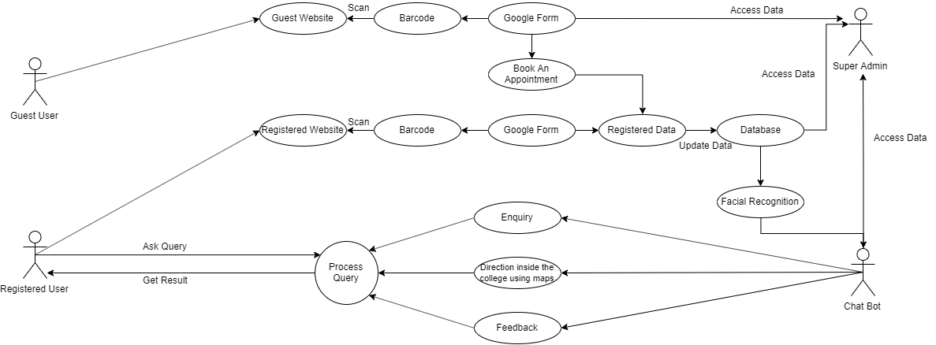

**Figure (4.3)**

Page No.9

**CHAPTER 5**

**IMPLEMENTATION**

5.1 **System Architecture-**

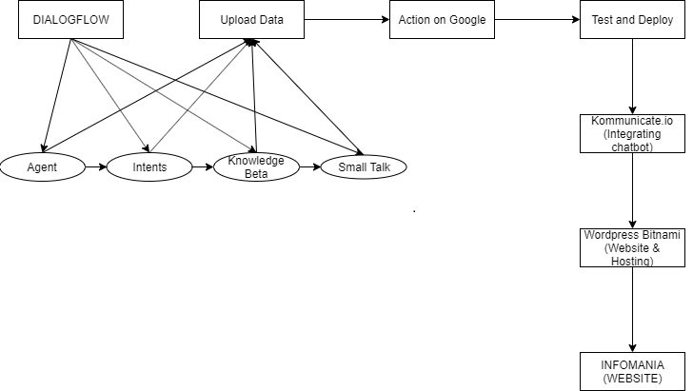

5.2 **Procedure**

Infomania is a state of being overloaded with information. We are using a chatbot with Facial recognition having two users(guest and registered user). The camera module will scan a user’s face and check if the face has a match in the database. If there are no matches present then the user is presented with a barcode which will then provide the user with a link which will lead him/her to a google form. The google form will take the basic details(Name, Email_ID, Phone_Number) of the guest user. The email which will be sent for confirmation will have the link to the Infomania website. The users whose faces have been found in the database will be provided with a different barcode which will directly lead you to the Infomania website.

For accessing data in the website users will be provided with a virtual assistant named Infomania that processes queries and provides responses to the user. We have three procedural phases:

Page No.10

Step 1: Facial Recognition

Step2: Website

Step3: Conversational AI

5.3 **Pseudo Code**

*get arguments from the command line*

*load the known faces and embeddings along with OpenCV's Haar cascade for face detection*

*data=get data from the pickle file*

*vs=initialize video stream*

*frame=grab a frame from the video*

*gray=grayscale(frame)*

*rgb=BGRtoRGB(frame)*

*rects=detectfaces(gray)*

*boxes=initialize the size of boxes*

*encodings=compute the facial embeddings for each face bounding box*

*Loop until all encodings have been cycled through:*

*matches=compare(frame,encodings)*

*name=UNKNOWN*

*if true in matches:*

*cycle thought names*

*end*

*end*

*if name is unknown:*

*show guest barcode*

*end*

*if name is not unknown:*

*how registered barcode*

*end*

*wait for key break*

Page No.11

**CHAPTER 6**

**RESULTS / SCREENSHOTS**

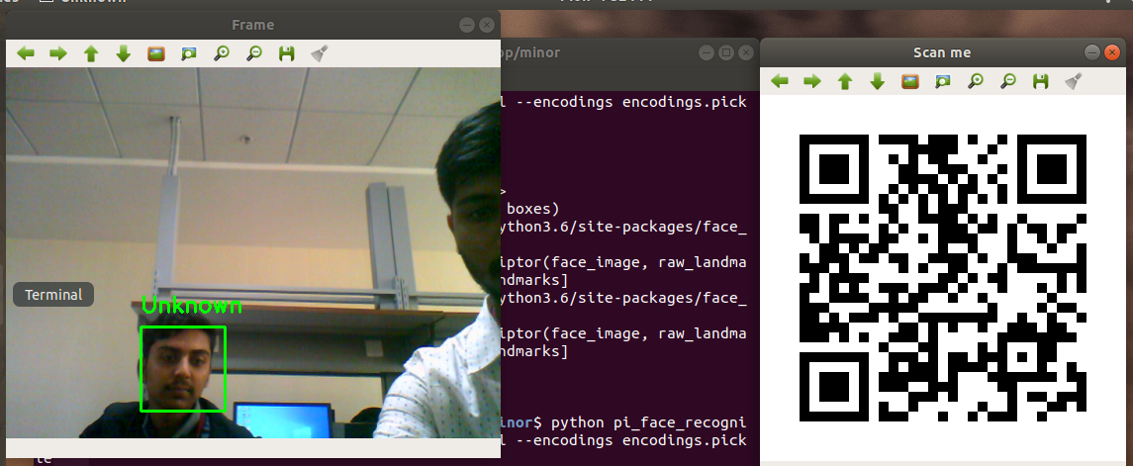

**Fig 6.1 -** Facial Recognition of Unknown Faces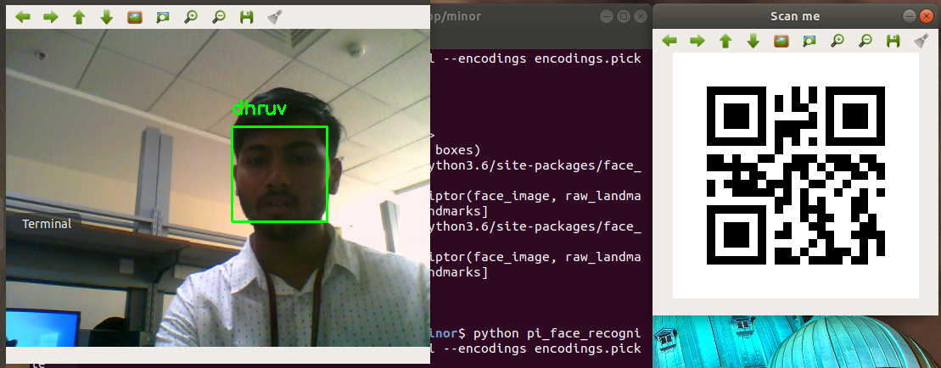

**Fig 6.2 -** Facial Recognition of Known Faces

Page No.12

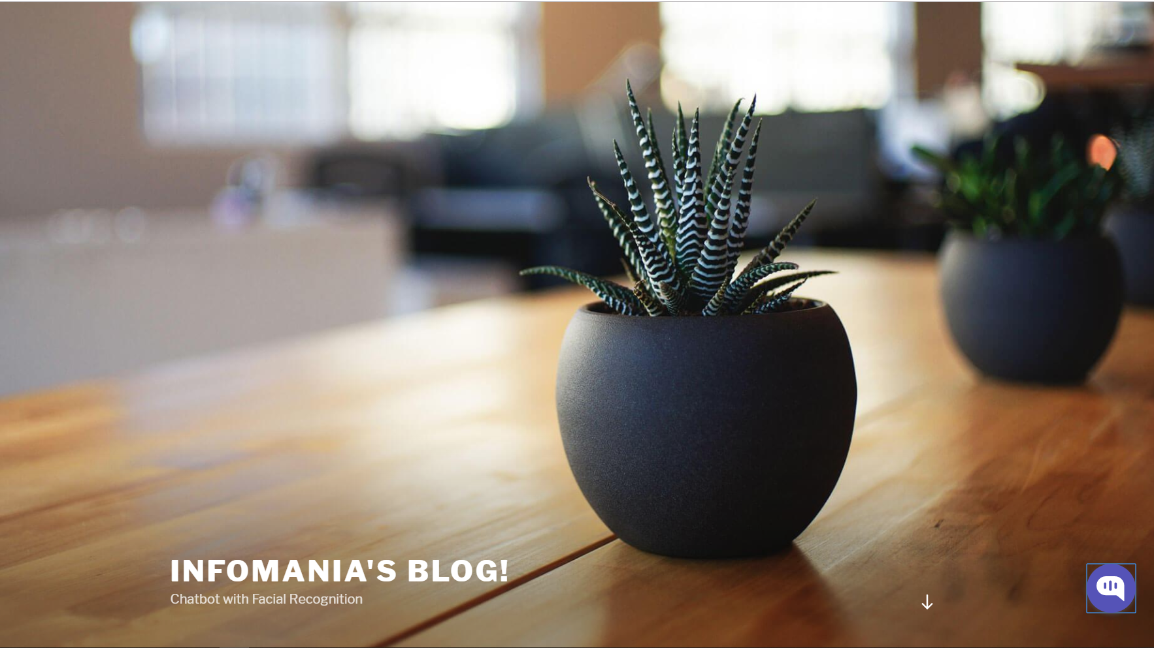

**Fig 6.1 -** Infomania Website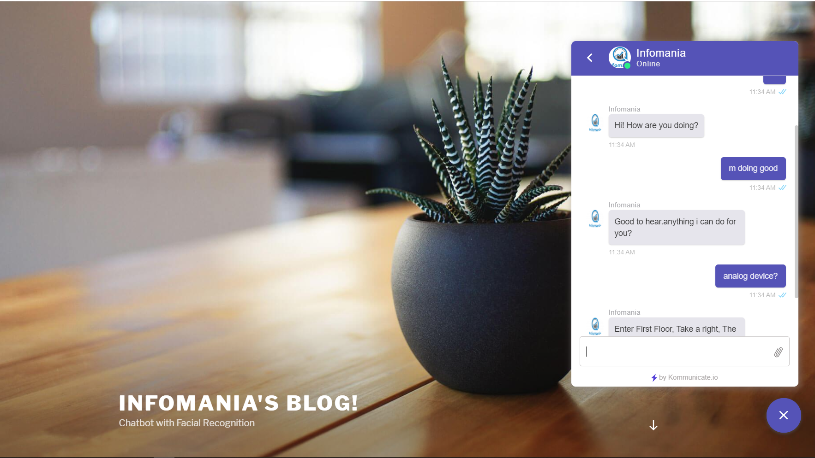

**Fig 6.2 -** Infomania Website With Chatbot!

Page No.13

**CHAPTER 7**

**CONCLUSION AND FUTURE SCOPE**

7.1 **Conclusion**

The proposed system would be a stepping stone in having in place an intelligent query handling program. An intelligent question answering system has been developed using the Naïve Bayesian concept. The system is capable of answering the query of the student in an interactive way using the chat agent that is used. Although there is still scope for improvement, the system performs fairly well in identifying the syntactically similar question and to a certain extent semantics is also considered. Also because we make use of a filtering process the search space is reduced and so the system becomes more efficient algorithmically.

7.2 **Future Scope**

We live in a corporate world so it is not surprising to see that more and more consumers are getting inclined to use chatbots. Of course, one might have to consider the human interaction that humans provide in chat service, but this conventional service from the human side got some limitations. This isn’t an issue with chatbots because of the wide range of services it provides and most importantly, the 24/7 availability. In the future, we can improve the chatbot’s responses and train facial recognition better. We can also work on actually integrating an indoor map.

Page No.14

**CHAPTER 7**

**REFERENCES**

[1] Implementation of a ChatBot System using AI and NLP (Tarun Lalwani, Shashank Bhalotia, Ashish Pal, Shreya Bisen, Vasundhara Rathod)

[2] Chat-Bot For College Management System Using A.I (Prof.K.Bala, Mukesh Kumar, Sayali Hulawale, Sahil Pandita)

[3] Facial Recognition with Local Binary Patterns(Timo Ahonen, Abdenour Hadid, Matti Pietikäinen)

[4] Face Recognition Using Eigenfaces (Matthew A. Turk and Alex P. Pentland)

Page No.15